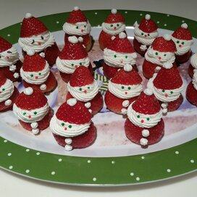

**Mini Strawberry Santa’s**

**Ingredients:**

1 pint fresh strawberries hulled

1 cup heavy whipping cream

1 tablespoon confectioners’ sugar

1 tablespoon chocolate sprinkles

**Directions:**

1. Cut the hulled-side strawberries so they can standup on a plate. Slice the tip off each strawberry to make the ‘hat’; set aside.
2. Beat cream and confectioners’ sugar in a glass or metal bowl until soft peaks form. Lift your beater or whisk straight up: the whipped cream will form soft mounts.
3. Spoon a large dollop of whipped cream on top of strawberry base for the ‘face’ and ‘beard’. Set the ‘hat’ atop the ‘face’. Add a dot of whipped cream, using a toothpick, on top of the ‘hat’ for a ‘pom-pom’ and 2 dots on the strawberry base for ‘buttons’. Place 2 sprinkles on the ‘face’ for ‘eyes’.

**Nutrition Facts (Per Serving)**

Calories 64 Prep: 20 minutes

Protein .5 g (1% DV) Total: 20 minutes

Carbohydrates 3.2 g (1% DV) Servings: 16

Fat 5.7 g (9% DV) Yield: 16 servings

Cholesterol 20.4 mg (7% DV)

Sodium 6 mg